# ✈️Screen Shot 08-19-25 at 12.43 PM.PNG XFMC Remote CDU Installation Guide (For Absolute Beginners)

This guide will walk you through installing and setting up the XFMC Remote CDU app on your tablet to work with X-Plane 12. No tech jargon—just clear instructions.

## 🧰 What You’ll Need

* A **10-inch Android tablet** (vertical orientation recommended)
* The **XFMC Remote CDU** .apk **file**
* A **Windows PC running X-Plane 12**
* Both devices connected to the **same Wi-Fi network**

## 📲 Step 1: Install the App on Your Tablet

1. **Transfer the** .apk **file** to your tablet. You can use a USB cable, email, or cloud storage like Google Drive.
2. On your tablet, **open the file**. You’ll be asked to allow installation from unknown sources.
3. Tap **“Allow”** or **“Accept”** for:
   * Unknown sources
   * Network access
   * App updates

Once installed, the app is ready to be configured.

On your PC, go to the folder:

X-Plane 12 > Resources > plugins > XFMC

• Find the file named XFMC.ini and open it with Notepad.

• Locate the following lines and change them to match this:

; Use Network for Tablet (1=yes, 0=no)

NetWork=1

; PortNumber for Network (std: 51713)

Portnumber=51713

## 🚀 Step 3: Start X-Plane and Find Your IP Address

1. Launch **X-Plane 12**.
2. Wait until the **XFMC window** appears.
3. Go back to the XFMC folder and open XFMC.txt using WordPad.
4. Look for a line like:

[NETWORK] Your PC IP: 192.168.1.248

## ⚙️ Step 4: Configure the App on Your Tablet

1. Open the **XFMC CDU app**.
2. Tap the **Settings icon** (top right corner).
3. Tap **“IP”** to open the network setup screen.
4. Enter:
   * **IP address**: 192.168.1.248 (or whatever yours is)
   * **Port number**: 51713
5. Tap **“Save”**.

## ✅ Step 5: Test the Connection

* If everything is set up correctly, the app will begin syncing with X-Plane.
* You’ll see **loading screens, waypoints, tracks**, and other FMC data.
* Success! You now have a working CDU on your tablet.

## 🧯 Troubleshooting Tips

If the app doesn’t connect:

* Make sure your **PC and tablet are on the same Wi-Fi network**
* Check your **firewall settings**—it may be blocking port 51713
* Restart both devices and try again
* If needed, **open port 51713** on your router

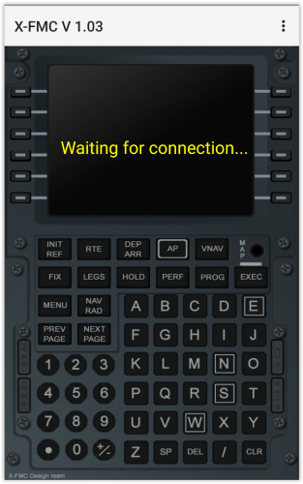

## 📲 The Settings Buttons Explained (for Dummies)

## Screen Shot 08-19-25 at 12.23 PM.PNG

When you open the **XFMC CDU app** on your tablet, you'll see a **Settings** button in the top right corner. Tap it, and you'll get four options:

### 🔘 EXIT

Closes the app. Simple. Tap this when you're done or want to restart.

### 🔘 IP

Here you enter the **IP address and port number** of your PC. 👉 You’ve already done this earlier in the guide. If you ever need to change it, this is where to go.

### 🔘 ResetTracks

Always use this when starting a **new flight**. ✈️ Why? Because otherwise the app might still show old tracks and waypoints from your previous flight. 🧹 This button clears everything and gives you a clean slate for your new route.

### 🔘 Update

Tap this to check if there’s a **new version** of the app available.

* If there’s **no update**, nothing happens.
* If there **is**

## 🛑 MAP Button ≠ Map DisplayScreen Shot 08-19-25 at 12.46 PM.PNG

In the **XFMC CDU app**, you’ll see a **MAP** button on the screen. But beware: this is **not** a map feature like the one in X-Plane XFMC itself!

### In the XFMC Remote App:

🟢 The **MAP** button activates **screen lock** → Your screen stays on and won’t go into sleep mode → Very useful during long flights.

### In XFMC for X-Plane:

🗺️ The **MAP** button opens the **navigation map** → You’ll see your route, aircraft position, and waypoints.

👉 To view the map in **XFMC Remote**, swipe left on the CDU screen. That’s where you’ll find the **interactive map with live data**.

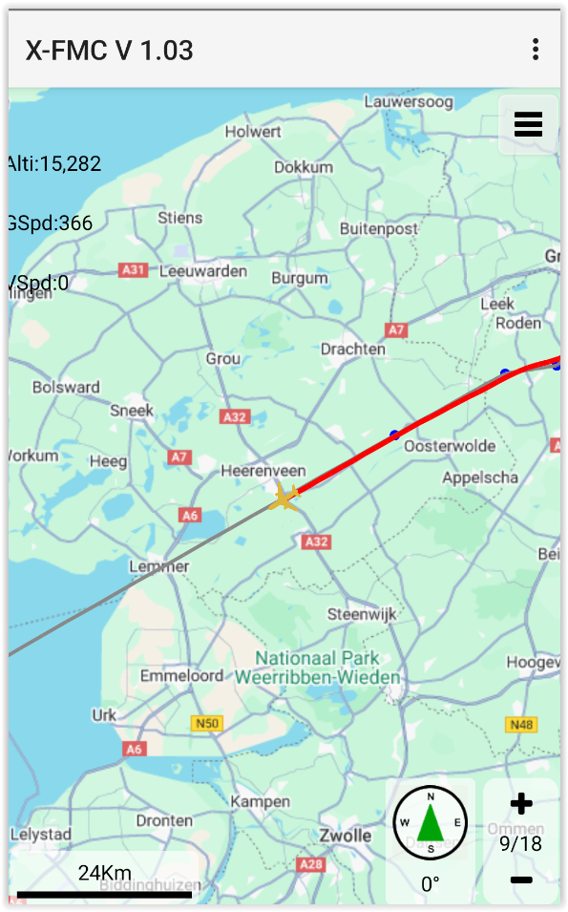

🗺️ Live Map Navigation – Advanced

### Swipe to See the Map

* Swipe **left** on the CDU screen
* You’ll see a **map** with your route and airplane
* Swipe **right** to go back to the CDU

When your simulator is running and the **XFMC CDU** is properly connected, the map will display:

* ✈️ Your aircraft in **real-time**, flying over the landscape
* 🛤️ The **route you’ve flown** (track line)
* 📊 **Live flight data** on the left side of the screen:
  + **Alti**: Altitude in feet
  + **GSpd**: Ground speed in knots
  + **VSpd**: Vertical speed (climb/descent rate)

🖼️ Example: Active map view over the Netherlands